

PRESS STATEMENT ON THE POTENTIAL DISASTER IMPACTS OF MARCH - MAY 2026 SEASONAL RAINFALL OUTLOOK AND
PREAPREDNESS AND MITIGATION MEASURES TO BE UNDERTAKEN

OFFICE OF THE PRIME MINISTER

MARCH, 2026
Dear members of the Press,
I warmly welcome you all to this press briefing on the anticipated disaster impacts of the country’s first seasonal rains, following the release of The March–April–May (MAM) 2026 Seasonal Rainfall Outlook by the Ministry of Water and Evironment. This outlook provides a detailed forecast of the first rainfall season as illustrated below:
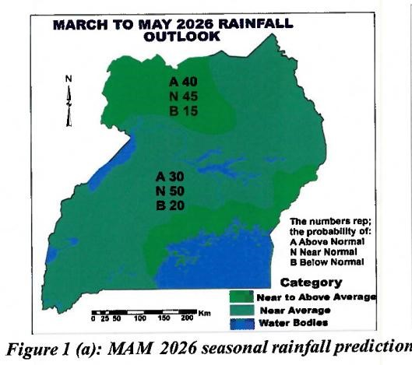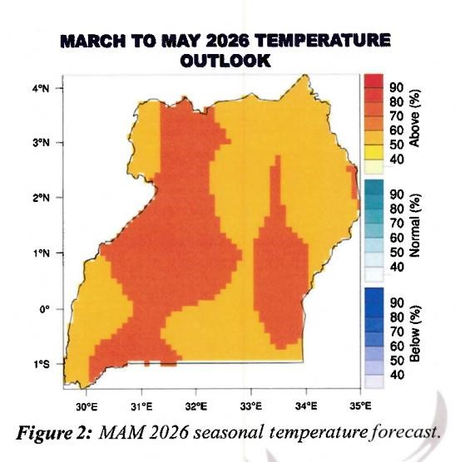

The Government of Uganda wishes to inform the public that, according to the March–April–May (MAM) 2026 seasonal forecast, most parts of the country are expected to receive near-average rainfall. However, the Northwestern region, areas around Lake Victoria, and parts of the Eastern region are likely to experience nearaverage to above-average rainfall during this period. The MAM 2026 seasonal temperature forecast indicates that the country is likely to experience generally warmer-than-normal.
Specifically, near- to above-average rainfall is expected in parts of West Nile, Lango, Rwenzori, Kigezi, some parts of Acholi, Bugisu, Bukedi, some parts of Teso and Buganda. Meanwhile, near-average rainfall is anticipated in Ankole, Karamoja, and parts of Busoga, Bunyoro, and Buganda.
1.0: Anticipated Disaster Risks and Impacts
Given this forecast, the country should prepare for the following potential impacts:
- Flooding and waterlogging in low-lying areas and on the lower slopes of Mount Elgon, including districts such as Butaleja, Rubanda, Kisoro, Amuru,
Obongi, Pakwach, Kayunga, Kalungu, Rakai, Kitgum, Otuke, Lamwo, Serere, Bukedea, and Kasese. This may result in destruction of livelihoods, and damages to infrastructure.
- Flash floods in Kampala and other cities, and urban authorities, potentially disrupting transport and business activities.
- Landslides, mudslides, and soil erosion in highland areas of Elgon, Rwenzori, and Kigezi.
- Hailstorms and strong winds at the onset of rains, which may affect Kibaale, Sembabule, Ibanda, Buvuma, Kalangala, Bukomansimbi, Isingiro, Mbarara, Mitooma, and Tororo.
- Increased incidences of livestock diseases and crop pests, including Fall Army Worm.
- Higher risk of water-related diseases such as cholera, typhoid, dysentery, and malaria.
Increased lightning strikes in high-risk districts such as Kisoro, Lamwo, Bushenyi, Ntungamo, Nwoya, Amuru, Busia, and Bugiri.
2.0: Government Preparedness Measures
The Government has undertaken the following measures to enhance preparedness and response:
- Completed registration of households, and procured land for resettlement of persons at high risk of landslides in the Elgon sub-region.
- Dissemination of the MAM seasonal weather forecast at regional level.
- Working with the Uganda Red Cross Society, strengthened community-level disaster risk management capacities.
- Dissemination of warning information through the Media.
- Procurement of relief food for communities likely to be affected during the MAM season.
3.0: General Public Advisory
We urge all stakeholders and communities to take note of the following advisories:
  - Disseminate early warning messages to vulnerable communities to enhance risk awareness.
  - Build the capacity of individuals, communities, and institutions to strengthen resilience.
  - The City, District and Urban Authorities activate District Contingency Plans for hotspot locations to reduce on the likely impacts of MAM seasonal rains on lives, livelihoods and service delivery.
  - Improve stormwater drainage systems and clear urban drainage channels, channels, especially in flood-prone areas.
  - Continuously monitor water levels in lakes and rivers to guide early warning alerts and mitigate flood risks.
  - Enhance safety mechanisms and rescue operations on major lakes and rivers to prevent drowning incidents.
  - Communities on steep slopes of Elgon, Rwenzori, and Kigezi highlands should remain on high alert and, where possible, temporarily relocate to host families in safer locations.
  - Drivers, cyclists, and pedestrians are advised to avoid crossing flooded road sections.
  - Motorists are advised to strictly observe speed limits during rainy weather, as reduced visibility and slippery road surfaces can significantly decrease braking effectiveness.
  - Harvest and store animal feed (silage and hay) in preparation for adverse weather conditions.
  - Promote good sanitation and hygiene practices to prevent diarrheal diseases such as cholera and dysentery.
  - Clear bushes around homesteads to prevent breeding of mosquitoes and sleep under insecticide treated Mosquito Nets.
  - Due to the severe storms and the increased risk of lightning, communities are urged to stay away from open areas, conductive materials, taking shelter under tall trees or buildings.
  - Institutions and Households should ensure safety by trimming the tree branches close to their buildings to avoid risk of falling trees and/ or branches on the roofs leading to destruction and damages on houses and other properties.
  - Cities and Urban authorities are advised to cover manholes, as pedestrians have often fallen into them, especially when crossing flooded walk ways and road sections.
  - We strongly encourage communities in sub-regions expected to receive abovenormal rainfall to take full advantage of the rains by maximizing water harvesting and increasing food production as coping mechanisms during the dry season and periods of scarcity.
As Government continues to monitor rainfall patterns and evolving weather conditions, we call upon District Disaster Management Committees and District Disaster Policy Committees to intensify community sensitization, closely monitor early warning signals, and encourage timely action at community level.
We extend our sincere appreciation to all development partners and agencies that continue to support the Government of Uganda in efforts to forecast, detect, prevent, and mitigate disaster risks.
For God and my Country.
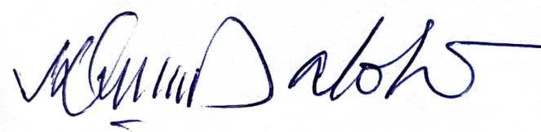
Eng. Hilary Onek (MP)
MINISTER OF RELIEF, DISASTER PREPAREDNESS AND REFUGEES.

